1.1)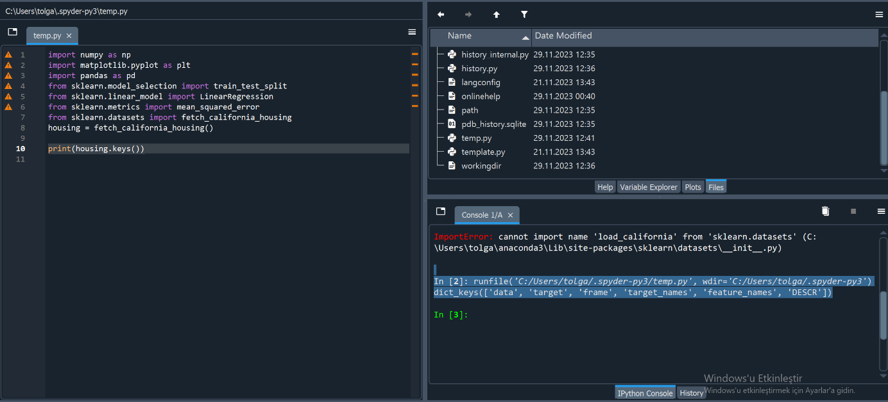

1.2)

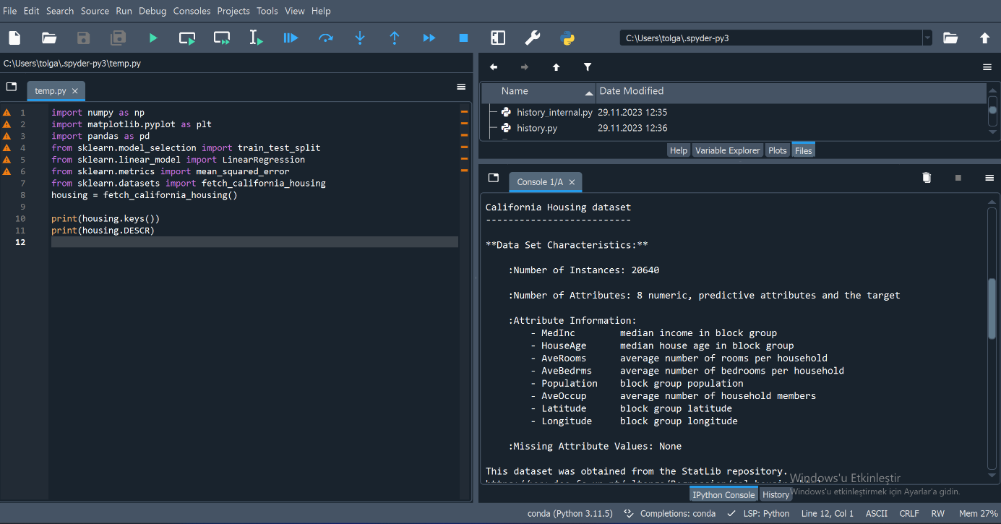

1.3)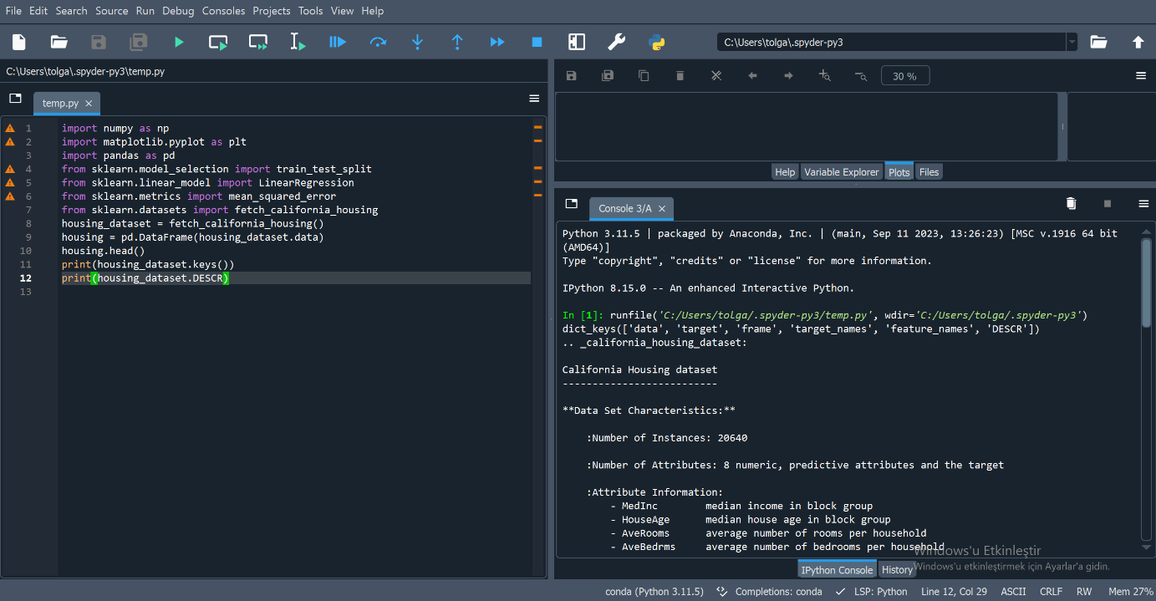

1.4)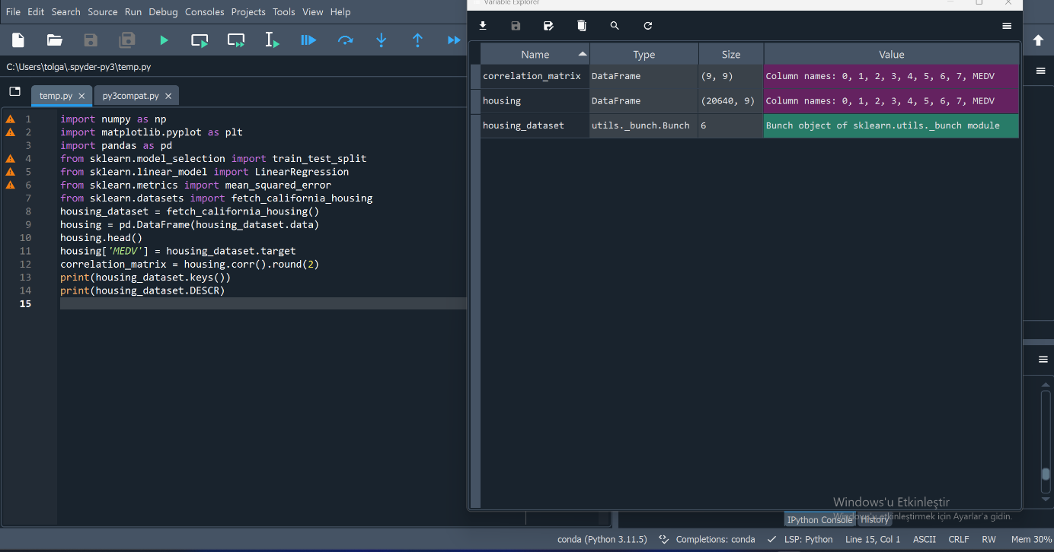

1.5)

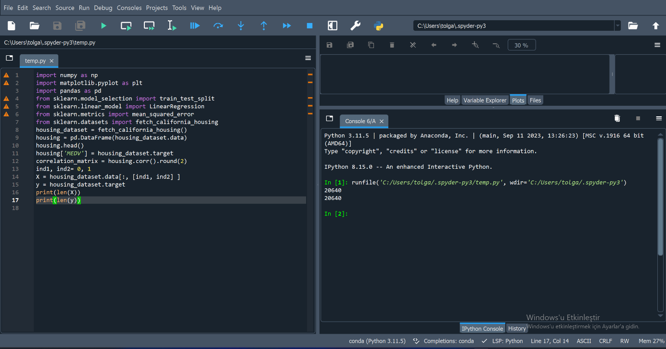  
The reason why the lengths of x and y are equal is that for each sample a vector (X) and a corresponding output value (y) are collected. It is represented by a row, a house or a block. Hence the lengths of x and y vary in data settings.

In this case, the lengths of x and y must be the same because both data are derived from the same sample set. This means you can have accurate input and output data to train and evaluate machine development models. If the lengths match, there will be a mismatch and problems may arise during model training or evaluation. Therefore, it is important that the lengths of x and y are equal.

1.6)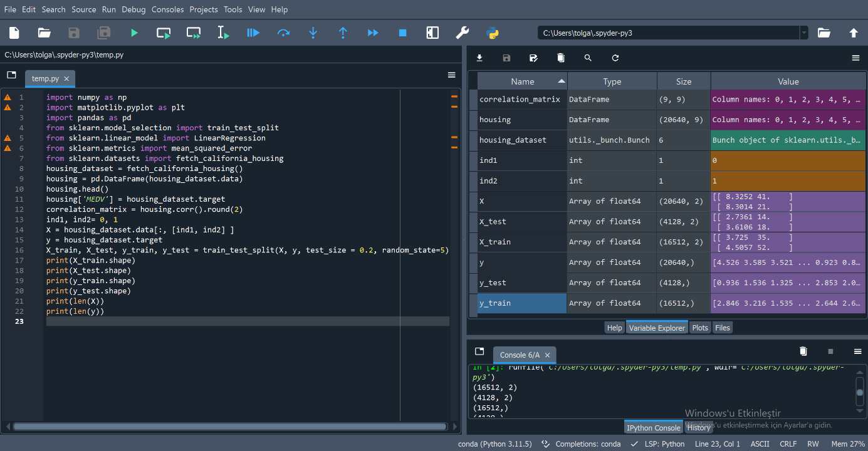

1.7)

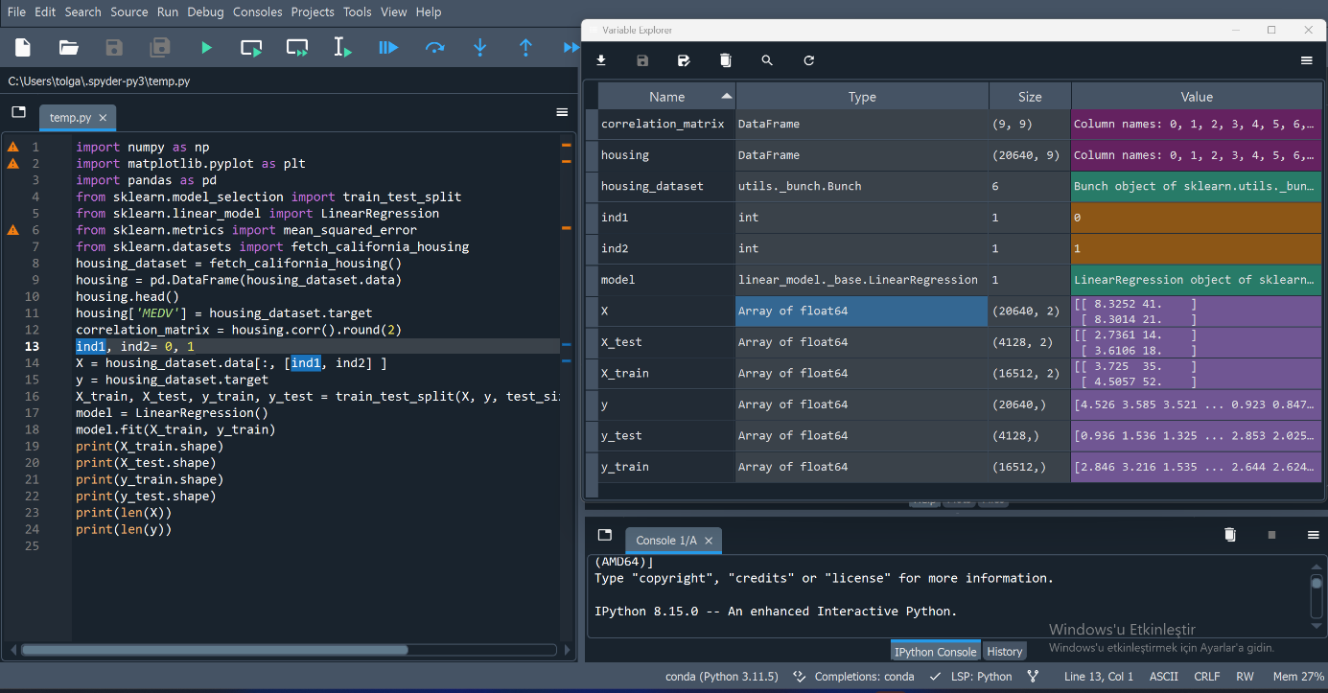

1.8)

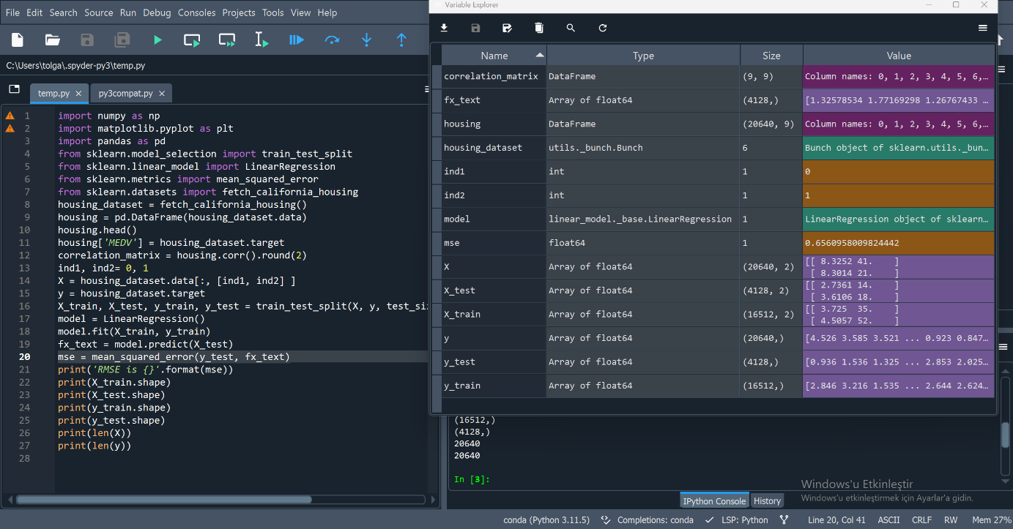

1.9)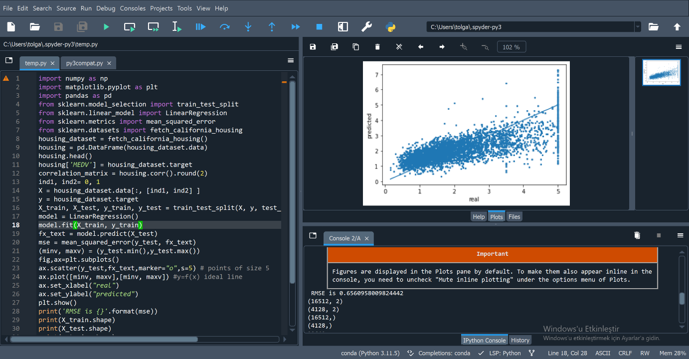

2.1)

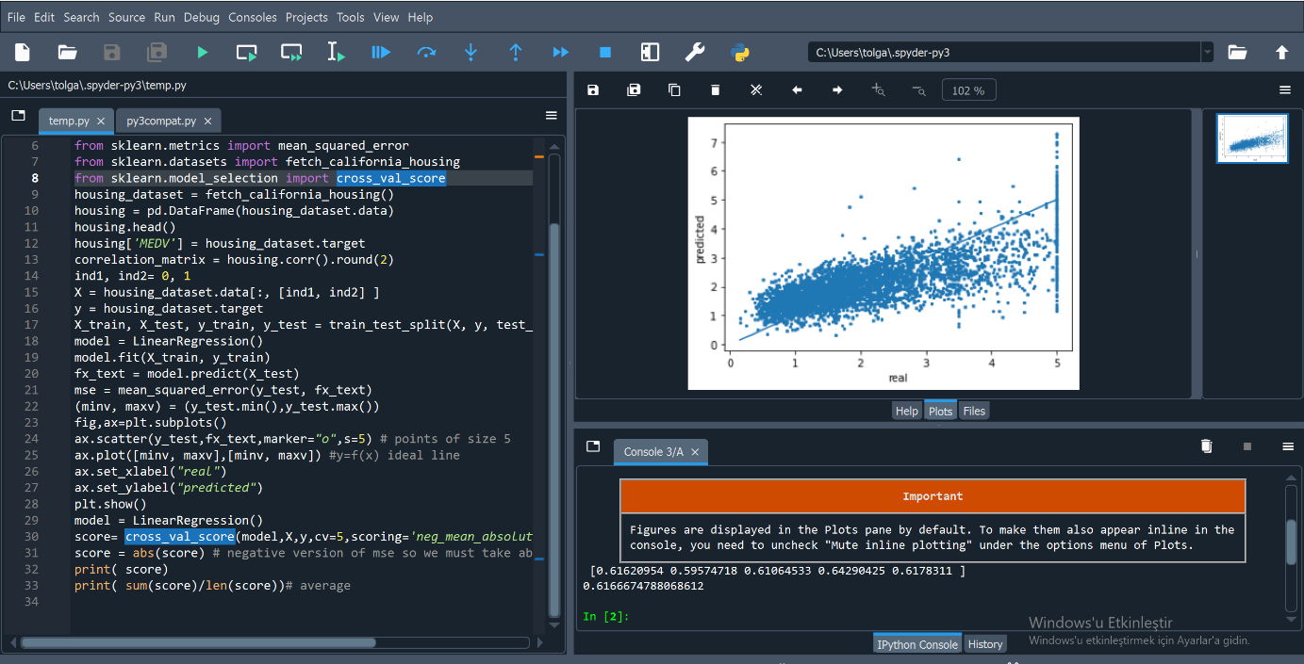

If the average cross-validation MSE is close to the validation set MSE, it suggests that the model is generalizing well to different subsets of the data.

If the average cross-validation MSE is significantly lower than the validation set MSE, it could indicate that the model is overfitting to the training set, and its performance doesn't generalize well to

2.2)

